Monday 1st July | Tuesday 2nd July | Wednesday 3rd July | Thursday 4th July | Friday 5th July
9Puzze  Games and Puzzles Challenge  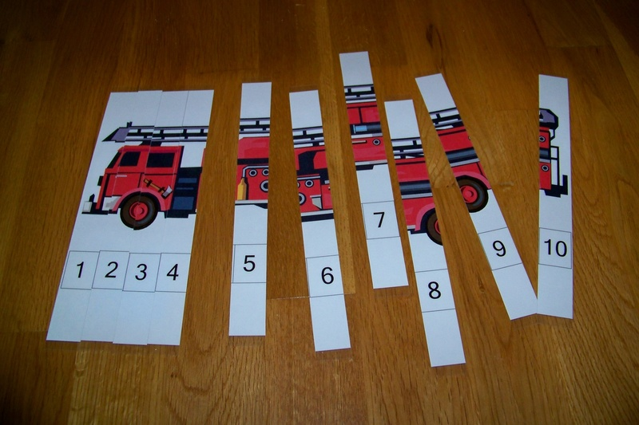  Puzzle | 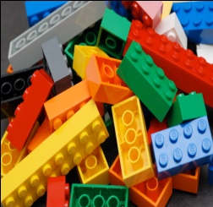  Bricks 4 Kidz | Sports & Games Challenge |  | “Secret Life of Pets 2”
Monday 8th July | Tuesday 9th July | Wednesday 10th July | Thursday 11th July | Friday 12th July
PJ Day & Face Paint | Ten Pin Bowling | Cooking up a storm  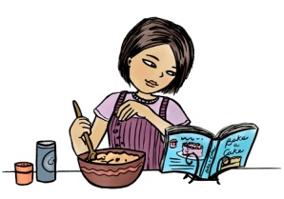 | “Toy Story 4” | ELECTRONICS  DAY  “

Games and Puzzles Challenge: Join in the games challenge competition; create your own puzzles or even a game to share with friends.
Bricks 4 Kids: Make some wonderful creations with Lego, let your imagination go and see what you are able to do.
Sports & Games Challenge: Challenge some others to one of our outdoor games or some of our planned sporting activities.
Clever Creations: Create, create, create. What can you make with some simple bits n pieces?
Movies: Let’s go to the movies. We head off to Warragul cinema to watch a show then to the local park to have some lunch. What new release will we see this time?
PJ Day & Face Paint: Come dressed for comfort with a design in mind, or choose from our delightful pictures.
Ten Pin Bowling: Face the challenge with your friends. See who will be a champ today
Cooking up a Storm: Yum, yum. What can we all cook together. Make some snacks to take home or something yummy to eat for your afternoon tea.
Movies: Let’s go to the movies. We head off to Warragul cinema to watch a show then to the local park to have some lunch. What new release will we see this time?
Electronics: Bring your own electronic tool. You can bring your phone, iPod etc.
Note: Children are not able to hotspot for the day. When discovered your device will be confiscated to be returned to your family member upon collection.

