Holiday Program 2025
Monday 7th July | Tuesday 8th July | Wednesday 9th July | Thursday 10th July | Friday 11th July
Circus Stars  INCURSION   | Face Painting & Crazy Hair  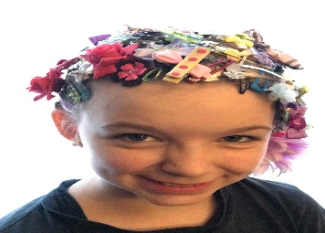  This Photo by Unknown Author is licensed under CC BY-NC-ND | Art & Crafts  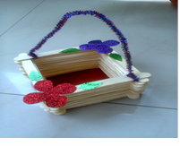 | Games Day  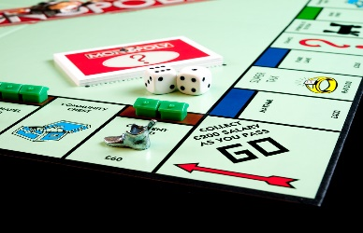 | Movies & Park  EXCURSION  
Monday 14th July | Tuesday 15th July | Wednesday 16th July | Thursday 17th July | Friday 18th July
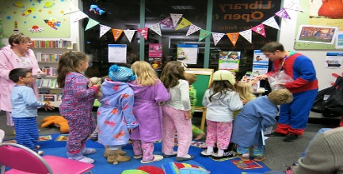  Pyjama Day | Master Chef   | 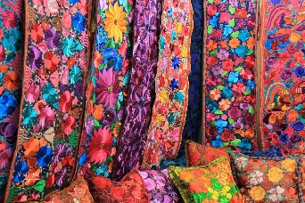  Textiles | Electronics Day   | Crazy Chemistry  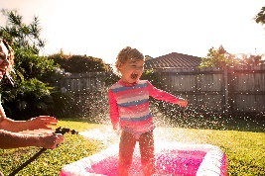  INCURSION
July 7th – July 18th
Circus Stars:(Incursion) Have a wonderful time learning some fantastic circus skills.
Face Painting & Crazy Hair: Create a fabulous hair do and match your face paint with it.
Arts & Craft: Look at the Indigenous art we can create for NAIDOC week. Let’s see what we can create, use your artistic talents and your fearless creative spirit.
Games Day: Enjoy a combination of simple board games, a chess challenge and some gym challenges both individual and teams
Movies & Park:(Excursion) Enjoy a movie with your friends at the cinema, then onto the park for lunch and some fun in the sun. Leave OSHC @ 9am, Return to OSHC approx. 3:00pm
Pyjama Day: Come dressed in your pj’s and chillax for the day.
Master Chef: Let’s do a cooking challenge to enjoy some great food
Textiles: Create your own toys, weaving, knitting, crochet and more. Have a go at something different
Electronic Day: Bring a long your own games, play with a friend or a small group. Note: No photos are to be taken of other children on personal devices. Brain breaks will be scheduled
Crazy Chemistry: (Incursion) Enjoy being a budding scientist and see what reactions you can get from simple household products
**** Your children have collaborated with our educators to plan our holiday program. They have all enjoyed this experience and are excited for the activities which have been planned for everyone to participate with. PCS Leap - OSHC

