Holiday Program 2026
Monday 21st Sept | Tuesday 22nd Sept | Wednesday 23rd Sept | Thursday 24th Sept | Friday 25th Sept
Stem Zone  “Electricity”  Incursion   | Art & Craft | Cube Sports  AFL  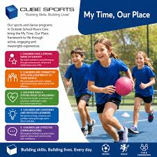  Incursion | PJ Day  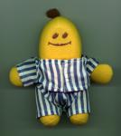 | PUBLIC HOLIDAY  CLOSED
Monday 28th Sept | Tuesday 29th Sept | Wednesday 30th Sept | Thursday 1st Oct | Friday 2nd Oct
Masterchef   | Incursion  Beyblade Challenge  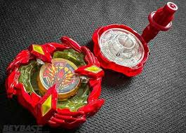 | 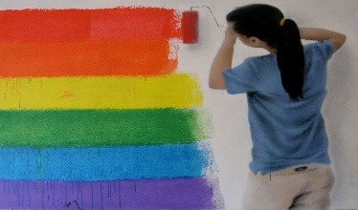  Sensory Art Day   | Minute 2 Win it Challenge   | Movies & Park    Excursion  Forgotten Island
September 21st – October 2nd
Stem Zone – Electricity (Incursion) Create some circuits, learn how electricity works Art & Craft: Create some beautiful art for our gallery Cube Sports(Incursion): AFL activities Pyjama Day: Have a relaxed and comfy day. Wear your favourite PJs. Watch a movie or two and chill out. PUBLIC HOLIDAY: CLOSED FOR THE DAY MasterChef: Cook up a storm Beyblade Challenge:(Incursion) Challenge your peers to a battle. Let’s see who will come out on top in the final challenge. Sensory Art: Help create an amazing sensory wall for everyone to use. Minute 2 Win It: What can you achieve in just one minute? Add your totals, count your limits and more to win the challenge cup. Movies & Park:(Excursion) Enjoy a movie with your friends at the cinema, then onto the park for lunch and some fun in the sun. Leave OSHC @ 9am, Return to OSHC approx. 3:00pm “Forgotten Island”.
**** Your children have collaborated with our educators to plan our holiday program. They have all enjoyed this experience and are excited for the activities which have been planned for everyone to participate in. Most inhouse activities aim to begin at 9am to enable a more relaxed environment.
PCS Leap - OSHC

