Holiday Program 2026
Monday 29th June | Tuesday 30th June | Wednesday 1st July | Thursday 2nd July | Friday 3rd July
Crazy Hair & Face Painting  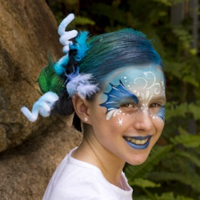 | Nerf Wars  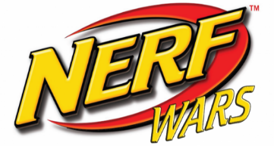 | Masterchef   | Incursion  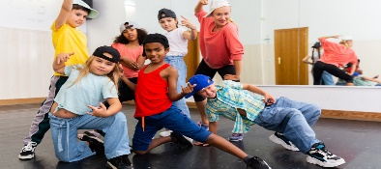  Dance | Children’s Choice  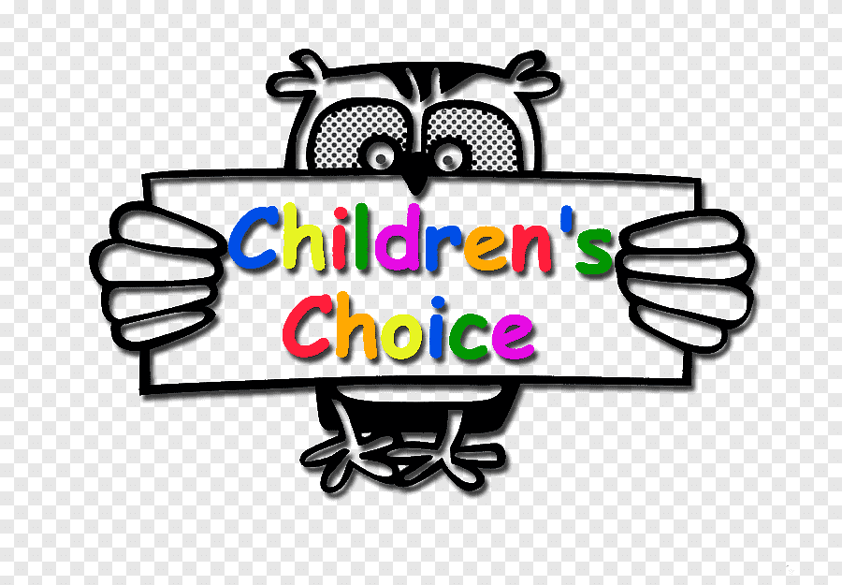
Monday 6th July | Tuesday 7th July | Wednesday 8th July | Thursday 9th July | Friday 10th July
Incursion  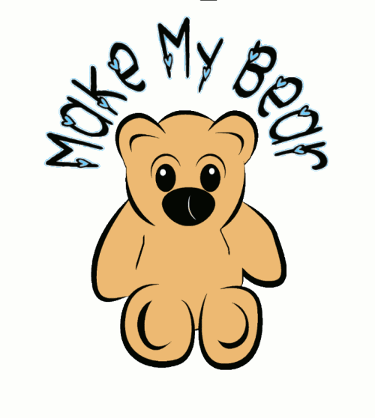 | 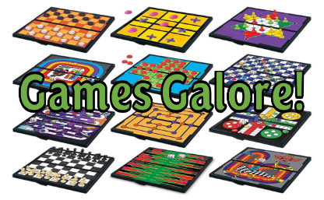 | Incursion Evasion & Invasion  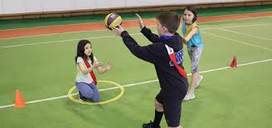 | Art & Craft  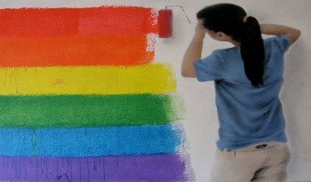 | Movies & Park    Excursion
June 29th – July 10th

Crazy Hair & Face Painting: Choose your favourite character for your face paint while creating your wonderful and weird hairdo Nerf Wars(Incursion): Choose your team wisely, score points and win the war Masterchef: Cook up a storm Dance(Incursion): Learn some wonderful new dance Children’s Choice: Relax after a big week. Choose your favourite activity to do for the day Make my Bear: (Incursion)Make your very own special toy to keep Games Galore: Have fun with the challenges between you and your friends Evasion & Invasion:(Incursion) Meet the challenge with the teams you support Art & Craft: Create some beautiful art for our gallery Movies & Park:(Excursion) Enjoy a movie with your friends at the cinema, then onto the park for lunch and some fun in the sun. Leave OSHC @ 9am, Return to OSHC approx. 3:00pm

**** Your children have collaborated with our educators to plan our holiday program. They have all enjoyed this experience and are excited for the activities which have been planned for everyone to participate in. Most inhouse activities aim to begin at 9am to enable a more relaxed environment.
PCS Leap - OSHC

