Monday 5th January Inc | Tuesday 6th January | Wednesday 7th January | Thursday 8th January | Friday 9th January
Stufflers  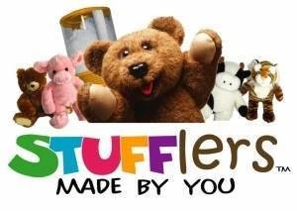 | Art & Craft  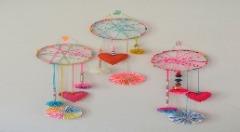 |   Billy Cart Bonanza – supreme | PJ’s   | Water works  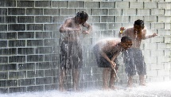
Monday 12th January Inc | Tuesday 13th January | Wednesday 14th January Exc | Thursday 15th January | Friday 16th January Inc
  Master Chef | Games challenge  Minute 2 win it    This Photo by Unknown Author is licensed under CC BY | Clip n Climb  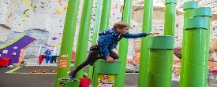 | Science activities   | Beaded blitz    This Photo by Unknown Author is licensed under CC BY-NC-ND
Monday 19th January Inc | Tuesday 20th January | Wednesday 21st January Inc | Thursday 22nd January | Friday 23rd January Exc
Silent Disco  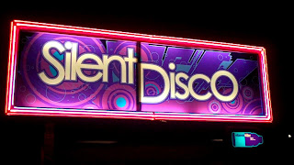 | Crazy Hair, Face Painting & Nails  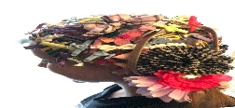 | Hip hop – supreme   |   Electronics Day | Movies  
Monday 26th January  PUBLIC HOLIDAY - CLOSED | Tuesday 27th January  PUPIL FREE DAY  Childrens Choice | Return to school for all children Wednesday 28th January  Foundation Pupil Free Day 29th & 30th Jan, 4th & 11th Feb.
Pakenham Consolidated School Learn, Explore and Play
Vacation Care Program
January 5th, 2026 – January 23rd, 2026

Our holiday program is put together in consultation with the children who attend our service. Discussion with the children with guidance from our educators is what makes our program so successful. We take this time to thank your children for being part of this process and our OSHC family.
PCS Leap educators.

Activity with description
Stufflers: Children choose from varied skins to create their own item to take home. They can experience the craft of toy making at their own pace.
Art & Craft: Create some of your very own art works to enjoy and display.
Billy Cart Bonanza: (Incursion) Experience to fun of building a billy cart and driving it with your group
PJ’s: Chillax and come along in your comfortable Pyjamas. Just jump out of bed and turn up.
Water games: Have fun in the sun with our water games activity. Hats must be worn. Bring a change of clothes and a towel we will be getting wet.
MasterChef: Cook up a storm in our kitchen.
Games challenge “Minute 2 Win it”: Let’s find our new champions with some of our old tasks and create a few new challenges as well
Clip n Climb: (Excursion) Experience the great rock-climbing walls at this fabulous place. All safety measures are taken for children to experience something new or enjoy the fun again.
Science activities: Let’s see what our budding scientists can do this time. Make a squishy egg, blow up something, create rockets and more
Beaded blitz: What beautiful items are you going to make?
Silent Disco: (Incursion) Dance party with a twist. Have headphones on while you dance along to the tunes piped directly to you
Crazy hair, Face painting & Nails: Lets just have a glam day with a twist
Hip Hop: (Incursion) Learn some new moves with our amazing dance teacher. Maybe a performance at the end for all to see.
Electronics: Children bring their own items to play. All items must be labelled in some way. Please note NO photos are to be taken, inappropriate use of items will result in confiscation of device for the day and parents being contacted.
Movies and Park: (Excursion) Come with our group to experience the adventures at the cinema. Get lost in the big screen, then head to the outdoors to the local park for some playtime and lunch before heading back to OSHC. A great way to end the week.
Monday 26th January: We are CLOSED for the Australia Day Public Holiday
Pupil Free Day: Children’s Choice. Varied activities offered in a relaxed atmosphere before returning to school.
Wk 1: All children return to or start school on Wednesday January 28th, 2026
Foundation children have pupil free days on Thursday 29th and Friday 30th January, then return to school on Monday 2nd February.

