Holiday Program 2026
Monday 6th April | Tuesday 7th April | Wednesday 8th April | Thursday 9th April | Friday 10th April
  PUBLIC HOLIDAY | Art Attack   | Masterchef   | Excursion   | PJ Day  
Monday 13th April | Tuesday 14th April | Wednesday 15th April | Thursday 16th April | Friday 17th April
Incursion  Wax Hands   | 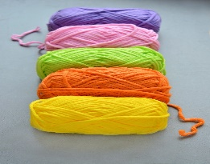  Wicked Wool |   Incursion | 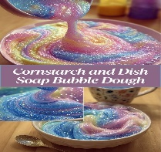  Sensory Activity Day | Movies & Park    Excursion
April 6th – April 17th
Public holiday: CLOSED Art Attack: What can we get our hands on this time. Use your imagination and maybe some sticky tape Masterchef: Cook up a storm again Inflatable World(Excursion): Bounce til you drop with a bunch of your friends PJ day: Relax after a big week. Come in your PJ’s and chill Wax Hands: (Incursion)Make your very own hand into a wax form Wicked Wool: Create some interesting items with wool. Weave, knit, crochet and more. Wildlife Xposure:(Incursion) Australian Animals Sensory Activities: How about we create some gooey sticky stuff, or some fluffy fun bits n bobs. What can we all make and do with various ingredients to have something fun to play with? Movies & Park:(Excursion) Enjoy a movie with your friends at the cinema, then onto the park for lunch and some fun in the sun. Leave OSHC @ 9am, Return to OSHC approx. 3:00pm

**** Your children have collaborated with our educators to plan our holiday program. They have all enjoyed this experience and are excited for the activities which have been planned for everyone to participate in. Most inhouse activities aim to begin at 9am to enable a more relaxed environment.
PCS Leap - OSHC

