Anaphylaxis Policy

Purpose

To explain to Pakenham Consolidated School parents, carers, staff and students the processes and procedures in place to support students diagnosed as being at risk of suffering from anaphylaxis. This policy also ensures that Pakenham Consolidated School is compliant with Ministerial Order 706 and the Department’s guidelines for anaphylaxis management.

Scope

This policy applies to:
- all staff, including casual relief staff and volunteers
- all students who have been diagnosed with anaphylaxis, or who may require emergency treatment for an anaphylactic reaction, and their parents and carers.

Policy

School Statement
Pakenham Consolidated School will fully comply with Ministerial Order 706 and the associated guidelines published by the Department of Education and Training.

Anaphylaxis

Anaphylaxis is a severe allergic reaction that occurs after exposure to an allergen. The most common allergens for school-aged children are nuts, eggs, cow’s milk, fish, shellfish, wheat, soy, sesame, latex, certain insect stings and medication.
Symptoms
Signs and symptoms of a mild to moderate allergic reaction can include:
- swelling of the lips, face and eyes
- hives or welts
- tingling in the mouth.
Signs and symptoms of anaphylaxis, a severe allergic reaction, can include:
- difficult/noisy breathing
- swelling of tongue
- difficulty talking and/or hoarse voice
- wheeze or persistent cough
- persistent dizziness or collapse
- student appears pale or floppy
- abdominal pain and/or vomiting.
Symptoms usually develop within ten minutes and up to two hours after exposure to an allergen, but can appear within a few minutes.

Treatment

Adrenaline given as an injection into the muscle of the outer mid-thigh is the first aid treatment for anaphylaxis.
Individuals diagnosed as being at risk of anaphylaxis are prescribed an adrenaline autoinjector for use in an emergency. These adrenaline autoinjectors are designed so that anyone can use them in an emergency.

Individual Anaphylaxis Management Plans

All students at Pakenham Consolidated School who are diagnosed by a medical practitioner as being at risk of an anaphylactic reaction must have an Individual Anaphylaxis Management Plan. When notified of an anaphylaxis diagnosis by written validation of a completed ASCIA Anaphylaxis Plan. The Principal or delegate will develop an individual anaphylaxis management plan in partnership with the student’s parents/carers in consultation with the treating health care professional.
Where necessary, an Individual Anaphylaxis Management Plan will be in place as soon as practicable after a student enrols at Pakenham Consolidated School and where possible before the student’s first day.
Parents and carers must:
- obtain a current ASCIA Action Plan for Anaphylaxis from the student’s medical practitioner and provide the original copy to the school as soon as practicable.
- immediately inform the school in writing if there is a relevant change in the student’s medical condition and obtain an updated ASCIA Action Plan for Anaphylaxis
- provide an up-to-date photo of the student for the ASCIA Action Plan for Anaphylaxis when that Plan is provided to the school and each time it is reviewed
- provide the school with an unexpired, prescribed adrenaline autoinjector for the said student.
- participate in annual reviews of the student’s Plan.
Each student’s Individual Anaphylaxis Management Plan must include:
- information about the student’s medical condition that relates to allergies and the potential for anaphylactic reaction, including the type of allergies the student has.
- information about the signs or symptoms the student might exhibit in the event of an allergic reaction based on a written diagnosis from a medical practitioner
- strategies to minimise the risk of exposure to known allergens while the student is under the care or supervision of school staff, including in the school yard, at camps and excursions, or at special events conducted, organised, or attended by the school
- the name of the person(s) responsible for implementing the risk minimisation strategies, which have been identified in the Plan
- information about where the student's medication will be stored
- the student's emergency contact details
- an up to date ASCIA Action Plan for Anaphylaxis completed by the student’s medical practitioner.
Review and updates to Individual Anaphylaxis Management Plans
A student’s Individual Anaphylaxis Management Plan will be reviewed and updated on an annual basis in consultation with the student’s parents/carers as required or on presentation of an updated ASCIA

anaphylaxis plan. The plan will also be reviewed and, where necessary, updated in the following circumstances:
- as soon as practicable after the student has an anaphylactic reaction at school
- if the student’s medical condition, in so far as it relates to allergy and the potential for anaphylactic reaction changes
- when the student is participating in an off-site activity, including camps and excursions, or at special events including fetes and concerts.
Our school may also consider updating a student’s Individual Anaphylaxis Management Plan if there is an identified and significant increase in the student’s potential risk of exposure to allergens at school.

Location of plans and Prescribed adrenaline autoinjectors
- A copy of the student’s Individual Anaphylaxis Management Plan will be provided to their Classroom Teachers, Parent/Carer and available to any Staff on request.
The prescribed student’s adrenaline autoinjector will be housed with a copy of the student’s current ASCIA Anaphylaxis plan and stored in accordance with the student’s Individual Anaphylaxis Management Plan.

Risk Minimisation Strategies – Universal Safeguards

Food Allergies

Canteen (Contractor)
- Canteen staff trained to minimise cross contamination of food during its preparation and processing.
- Canteen staff to use their discretion in stocking items of potential allergens.
- Canteen Staff alerted to the food allergy by the child’s parent and PCS.
- Canteen orders from children with a food allergy notated with “Food Allergy – Nuts” in large print on the paper bag, above or below the student’s name to alert or remind new Canteen Staff or Volunteers.
- Canteen Staff to be familiar with the Education Department policy relating to Canteen guidelines and healthy foods guidelines and any updates in this policy.
- Canteen Menu to include the foot note or similar.

“Please Note: If your child has a food allergy, please remind canteen staff by stating the student’s allergy in writing on the lunch paper bag in bold print (i.e. PEANUT ALLERGY). All reasonable care is taken at all times”.

Class Parties/Student Birthday’s

- Parent/Carers to supply a container housing safe food items to be consumed as a substitute for classroom activities (i.e. classroom parties, birthday party cake, treats, etc) that involve food consumption.
- Parents/Carers of the class with a student at risk of anaphylaxis provided with an information sheet/notice discouraging bringing food to school containing the allergen of concern.

- Advise/consult parent/carer of the birthday food being provided by third provider and receive consent

General

- Educate class about food allergies
- Encourage students and parents NOT to bring high risk food to school, if possible.
- Discourage food sharing between all children
- Encourage hygiene practise (i.e. frequent hand washing)
- Discourage food swapping between all children.
- Allow student to make own food items
- Allow student to touch own food products
- Staff will participate in accredited eLearning Anaphylaxis Courses
Students will use tongs or disposable gloves for picking up rubbish

Visual Arts/Crafts/Hobbies

Do not use items that may contain traces of the identified allergen even if washed thoroughly (i.e. food containers)

Performing Arts

- Do not use props or staging materials that may contain traces of the identified allergens.
Do not use costumes or make up that may contain traces of the identified allergens

Curriculum – Cooking

- Ensure food items do not conflict with child’s known allergens
- Prevent cross contamination of foods during preparation, cooking and distribution processes.

Insect Allergies

- Play in areas with few plants in flower to lessen contact with flying insects.
- Use an insect repellent, if appropriate.
- Wear clothing that covers all exposed skin where possible.
- Wear shoes at all times outdoors.
- Reduce bee attracting plants in vicinity (i.e. class room)
- Don’t house cut flowers or plants in flower in an indoor area where a child with an allergy resides.
- Don’t reside near sugar drinks that attract Wasps if allergic to their venom.

Latex/Related Allergies

- Use non-latex glove as an alternative
- Avoid use of party balloons
- Avoid contact with latex products
- Avoid contact with dressing strips with latex adhesive or components

Insect Sting Allergies

- Avoid being outdoors at certain times of the day where possible
- Using personal insect repellent that contains DEET (Diethyltoluamide, N, N-diethyl-3-methylbenzamide)
- Wear clothing that covers exposed skin
- Care around bodies of water that attract bees/insects
- Chlorinated pools attract bees
- Keep water bottle/open drinking vessels covered
- Don’t provoke bees/wasps’ nest or ant moulds or insects
- Consider garden plants that are not pollinated by insect of concern.

Adrenaline autoinjectors for general use

Pakenham Consolidated School will maintain a supply of adrenaline autoinjectors for general use, as a back-up to those provided by parents/carers for specific students, and for students/staff/visitors that may experience a first-time anaphylaxis reaction.
School Adrenaline autoinjectors for general use will be housed in the:
- First Aid Room
- Wellbeing Kitchen (Breakfast Club)
- Learn Explore And Play (LEAP) Building (houses Out of School Hours Care OSHC)
The Principal or delegate is responsible for the purchase of adrenaline autoinjectors for general use.

Emergency Response

In the event of an anaphylactic reaction, the emergency response procedures in this policy must be followed, together with the school’s general first aid procedures, emergency response procedures and the student’s Individual Anaphylaxis Management Plan.
A complete and up-to-date list of students identified as being at risk of anaphylaxis is maintained by First Aid Coordinator and stored on the First Aid Room Notice Board.
If a student experiences an anaphylactic reaction at school or during a school activity, school staff will provide a first aid assessment and follow the appropriate emergency response:

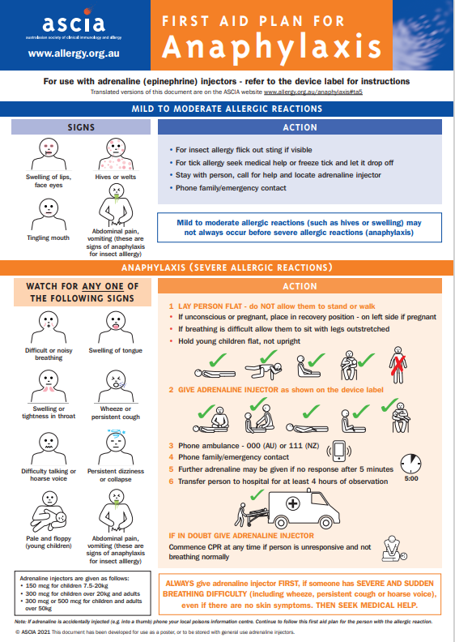

Step | Action
- Lay the person flat
- Do not allow them to stand or walk
- If breathing is difficult, allow them to sit
- Be calm and reassuring
- Do not leave them alone
- Seek assistance from another staff member or reliable student to locate the student’s adrenaline autoinjector or the school’s general use autoinjector, and the student’s Individual Anaphylaxis Management Plan.
- If the student’s plan is not immediately available, or they appear to be experiencing a first-time reaction, follow steps 2 to 5
Administer an EpiPen or EpiPen Jr (if the student is under 20kg)
- Remove from plastic container
- Form a fist around the EpiPen and pull off the blue safety release (cap)
- Place orange end against the student’s outer mid-thigh (with or without clothing)
- Push down hard until a click is heard or felt and hold in place for 3 seconds
- Remove EpiPen
- Note the time the EpiPen is administered
- Retain the used EpiPen to be handed to ambulance paramedics along with the time of administration
 | Call an ambulance (000)
 | If there is no improvement or severe symptoms progress (as described in the ASCIA Action Plan for Anaphylaxis), further adrenaline doses may be administered every five minutes if other adrenaline autoinjectors are available.
 | Contact the student’s emergency contacts.

If a student appears to be having a severe allergic reaction but has not been previously diagnosed with an allergy or being at risk of anaphylaxis, school staff should follow steps 2 – 5 as above.

Communication Plan
This policy will be communicated to our school community in the following ways:
- Included in staff induction processes and staff training
- Available publicly on our school’s website
- Discussed at staff briefings/meetings as required
- Discussed with parent/carer on or after enrolment school tours if required
- Hard copy available from school administration upon request
- Reminders in our school newsletter

The Principal is responsible for ensuring that all relevant staff, including casual relief staff, canteen staff and volunteers are aware of this policy and Pakenham Consolidated School’s procedures for anaphylaxis management. Casual relief staff who are responsible for the care and/or supervision of students will be briefed by their Team Teacher as to the identity of the students in their care that are identified as being at risk of anaphylaxis and any other matters.

Staff training
The Principal will ensure that the following school staff are appropriately trained in anaphylaxis management:
- School staff who conduct classes attended by students who are at risk of anaphylaxis
- All School staff are encouraged to complete the following course in anaphylaxis:
  - ASCIA anaphylaxis e-training VIC 2021-2 (theory component)
  - Anaphylaxis Supervisor (practical component)
Staff who are required to undertake training must have completed:
- an approved face-to-face anaphylaxis management training course in the last three years, or
- an approved online anaphylaxis management training course in the last two years.
Staff are also required to attend a briefing on anaphylaxis management and this policy at least twice per year (In Term1 and Term 3), facilitated by a staff member who has successfully completed an anaphylaxis management course within the last 2 years (i.e. School Anaphylaxis Supervisor). Each briefing will address:
- this policy
- the causes, symptoms and treatment of anaphylaxis
- the identities of students with a medical condition that relates to allergies and the potential for anaphylactic reaction, and where their medication is located
- how to use an adrenaline autoinjector, including hands on practice with a trainer adrenaline autoinjector
- the school’s general first aid and emergency response procedures
- the location of, and access to, adrenaline autoinjectors that have been provided by parents or purchased by the school for general use.
When a new student enrols at Pakenham Consolidated School who is at risk of anaphylaxis, the Principal will develop an interim plan in consultation with the student’s parents and ensure that appropriate staff are trained and briefed as soon as possible.
A record of staff training courses and briefings will be maintained on the PCS OHS Training Planner.
The Principal will ensure that while students at risk of anaphylaxis are under the care or supervision of the school outside of normal class activities, including in the school yard, at camps and excursions, or at special event days, there is enough school staff present who have been trained in anaphylaxis management.

Further information and resources

- Allergy & Anaphylaxis Australia
- ASCIA Guidelines: Schooling and childcare
- Royal Children’s Hospital: Allergy and immunology
POLICY REVIEW AND APPROVAL
Policy last reviewed | 2021
Approved by | Principal
Next scheduled review date | 2022

The Principal or delegate will complete the Department’s Annual Risk Management Checklist for anaphylaxis management to assist with the evaluation and review of this policy and the support provided to students at risk of anaphylaxis.

